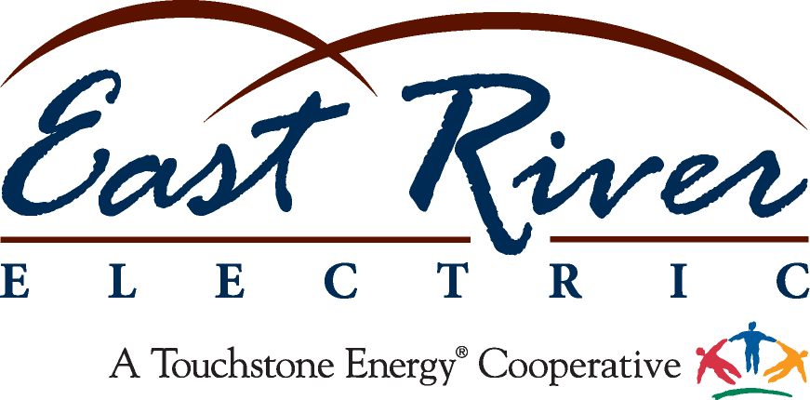

METER/RELAY TECHNICIAN

East River Electric is seeking an experienced Meter/Relay Technician with a primary focus in the protection and control aspect of electrical substation equipment, which has similarities to PLC logic and process controls.

This role will install, maintain, test, adjust, troubleshoot and repair substation equipment. This includes, but is not limited to, electromechanical, solid state and microprocessor protective relays, indicating meters, recording instruments, controls to all station apparatus including breakers, transformers, regulators, capacitors, reactors and all associated equipment, and remote control equipment including various forms of SCADA. The position will occasionally require working from ladders, structures and aerial bucket trucks to heights of approximately 40 feet.

This is a full-time regular position. The successful candidate for this role will have, or have the capability, to acquire working knowledge of substation protection, control, metering and RTU equipment.

Position Requirements:
- Associate degree in electrical construction, automation controls, substation, telecommunications, or powerline construction.
- A minimum of 5 years’ experience in electronic/electrical maintenance may be considered in lieu of a degree.
- Proficiency with computer technology to control, test, and program equipment, as well as the use of common and specialized tools and equipment.
- Excellent written and verbal communications skills.

East River Electric Power Cooperative, with a main campus in Madison, South Dakota, is a power supply cooperative that delivers wholesale power through a 3,000-mile transmission system to 25 member electric distribution systems throughout eastern South Dakota and western Minnesota. Our highly-skilled workforce embraces the seven cooperative principles and the values of integrity, accountability, innovation and commitment to community.

East River offers an excellent compensation package which includes health insurance, a retirement pension plan, and 401K plan contribution. A flexible 9/80 work schedule is also available which offers 9 hour work days with every other Friday off. There is a residency requirement for this position and the applicant selected will be required to live in close proximity to Madison, SD.

To learn more about East River and apply for this position, please visit www.eastriver.coop/careers and complete your electronic profile. Questions regarding the position can be directed to hr@eastriver.coop or (605) 256-4536.

Applications will be accepted until filled with initial review of applications beginning on February 1, 2018.

Equal Opportunity Employer
M/F/Disabled/Veteran

